Moonbi Public School Revised 2018

The Anti-Bullying Plan – NSW Department of Education: Normanhurst Public School
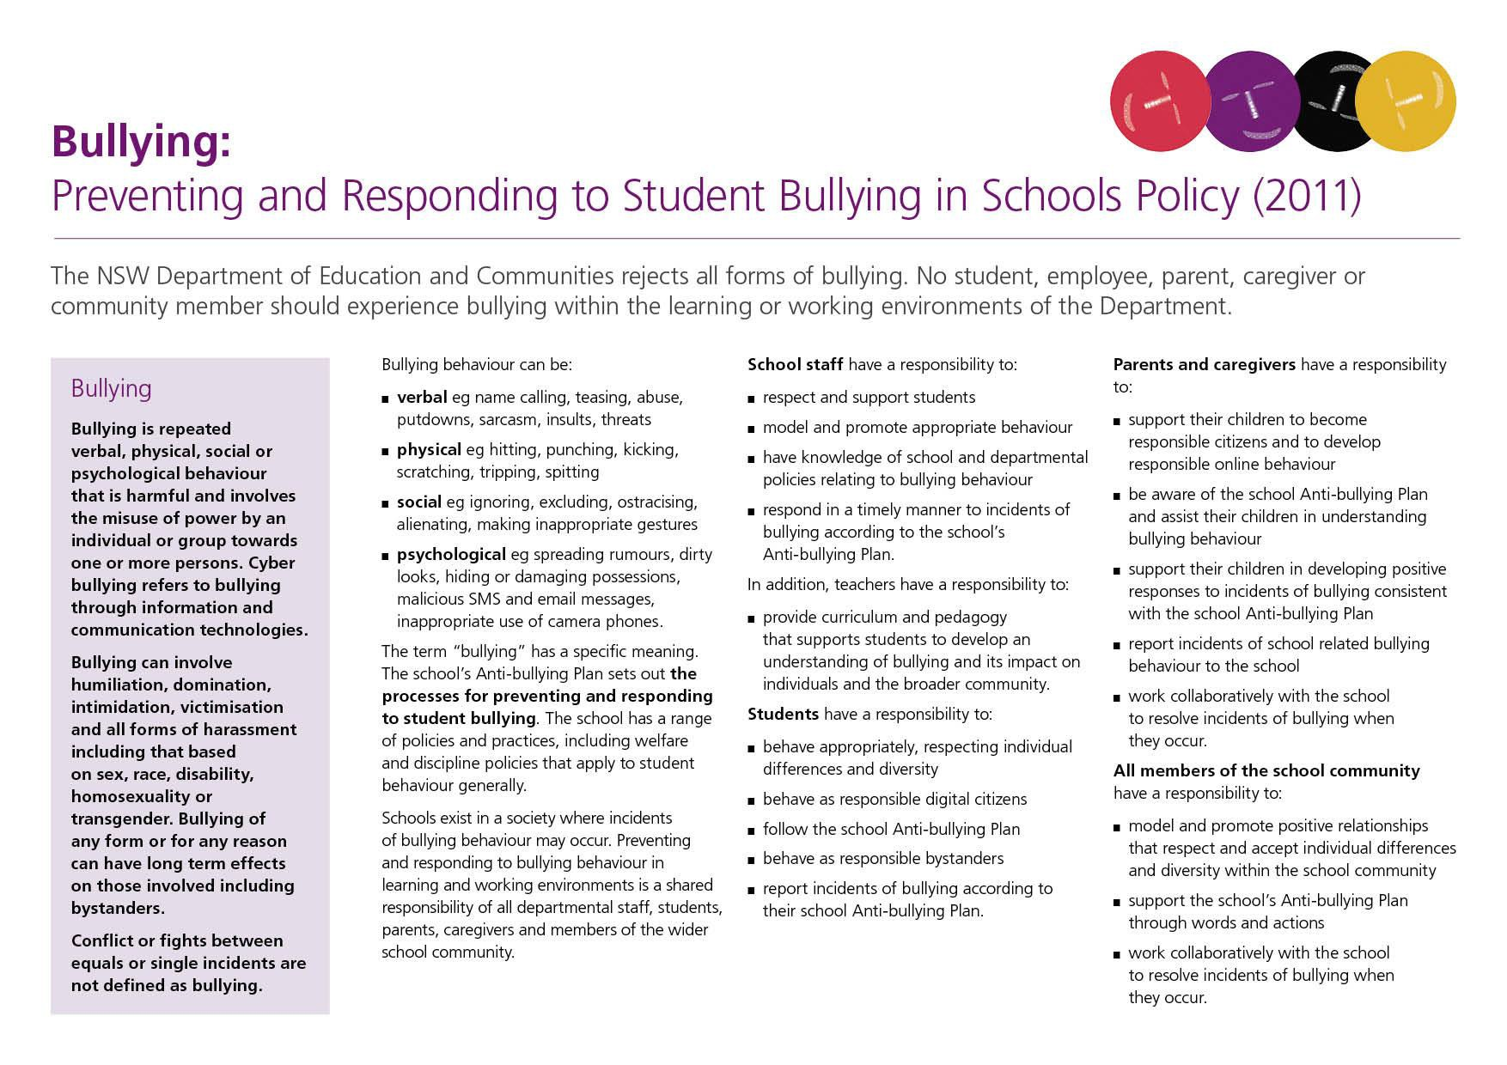

Our School Anti-Bullying Plan
This plan outlines the processes for preventing and responding to student bullying in our school and reflects the Bullying: Preventing and Responding to Student Bullying in Schools Policy of the New South Wales Department of Education.
The school community, including staff, the parent community and students provided input into the development of this plan through Tell Them From Me surveys and consultation regarding the Positive Behaviour for Learning (KIDSMATTER) program. The draft policy was presented to all stakeholder groups for input and consultation.

Statement of purpose
At Moonbi Public School we believe that all students have the right to learn in an environment where they feel safe and secure, physically and emotionally. We believe that all members of the school community have a responsibility to model and reinforce the high standards of behaviour expected of students and that these reflect the values of the community. At Moonbi Public School our approach to student wellbeing is centred on the KidsMatter program.

Protection
Students, staff, parents, carers and members of the wider school community have the right to feel safe and respected. All members of the school community have a shared responsibility to create a safe and happy environment, free from all forms of bullying (physical, verbal, cyber, social, psychological). We believe that a positive school climate of respectful relationships, that fosters student connection with both the school and the wider community, reduces the likelihood of bullying occurring. Any inappropriate behaviour that interferes with the wellbeing of the school community will not be accepted.

It is important that the school and its community have a clear understanding as to what constitutes bullying. Conflict, social difficulties or single incidents are not defined as bullying.

Prevention
The school community has a responsibility to address the underlying causes of bullying relating to school organisational issues, teaching and learning issues and relationship issues. Preventative strategies implemented by the school community will include:
- promotion of the school’s Anti-Bullying Plan
- explicit teaching of expectations through our social skills program
- cyberbullying module and instruction on safe and appropriate use of technology within school technology lessons
- regular activities and sessions that address positive behaviours, such as Brainstorm Productions, cyberbullying talks with the Police Youth Liaison Officer, Harmony Days and PDHPE lessons
- promotion of productive and respectful relationships between all members of the school community
- active supervision of students at all times in all school settings

Staff Responsibilities:
- Model appropriate behaviour at all times
- Track and monitoring students as per ebs procedures.
- Communicate any bullying behaviour to the classroom teacher / Principal and parents as required

Parent/ Carer Responsibilities:
- Model appropriate behaviour at all times
- Be aware of and support the school’s Anti-Bullying Plan and KidsMatter program
- Encourage their child to adopt learnt strategies to deal with bullying and promote positive social skills
- Monitor their child’s use of social media where it affects school life

Student Responsibilities:
- Behave in accordance with the school values at all times
- Inform a staff member if they are being bullied or they see someone being bullied
- Attempt to learn strategies to deal with bullying incidents in line with school programs

Early Intervention
If a student is identified as being at risk of developing long-term difficulties with social relationships, or has been identified as having previously experienced bullying or engaged in bullying behaviour, strategies to support them may include:
- Referral to the Principal/LST or School Psychologist
- Social support strategies (e.g. social stories, extra-curricular activities)
- Behavioural / cognitive assessment
- Individual behaviour plans and strategies

Response

Staff Response:
All staff members are committed to a common response to bullying. Immediate intervention is crucial and clear procedures are to be followed when a case of bullying is identified.

Teachers have a responsibility to address incidents of bullying in a timely manner as appropriate to the circumstances. Classrooms are to be positive, safe and supportive environments where negative behaviour is recognised and dealt with. The Principal will provide support to teachers so that they are able to maintain a safe classroom environment.

Staff will:
- Watch for signs of distress, isolation and suspected incidents of bullying
- Follow the school procedures and discipline plan for addressing incidents
- Recognise bullying behaviours as per definition detailed in this policy
- Educate students as to recognising and responding to bullying incidents
- Discuss student wellbeing concerns in student welfare meetings and staff meetings as appropriate
- Listen and provide support to the targeted student by acknowledging the nature, effects and seriousness of the bullying behaviour.
- Investigate the background and details of the incident by using strategies, which support all.
- Attempt to resolve the incident and achieve satisfactory resolution of the issues involved.
- Maintain open communication with students and their families.

Student Response:
The students will participate in a range of programs centred on anti- bullying. Students will:
- Recognise bullying as per definition detailed in this policy
- Report incidences of bullying to a staff member – for both students who have been bullied and students who have witnessed bullying

Parent / Carer Response:
Through the publication of this policy through the P & C and school website, parents / carers will be informed about procedures for addressing incidents of bullying.
Parents will:
- Recognise bullying behaviours as per definition in this policy
- Take a pro-active approach and talk with children if they suspect they are victims of bullying
- Approach the child’s teacher to discuss concerns
- Model and be responsible for encouraging anti-bullying behaviours

Procedures for dealing with reported bullying incidences:
When a bullying incident is reported or observed the following procedures will apply:
- Staff members are to report concerns of child wellbeing to the Principal. The Principal will assess the situation and a decision will be made on the appropriate action to be taken.
- Other staff are informed of the incident at the afternoon student welfare meeting.
- Victim(s), then bully(ies) interviewed informally.
- If clearly substantiated, bullies advised that if no further occurrence no further action will be taken. (Warning)
- Monitor the behaviour of the children involved.
- If bullying behaviour continues, parents of all involved are notified and consequence as determined through Discipline Strategies Flow Chart.
- If bullying continues, parents are again notified, a suspension warning is issued and the situation continues to be monitored.
- If bullying continues parents of students are notified, bully(ies) are suspended by Principal (number of days determined by Departmental guidelines).
- If it is noted that a student is repeatedly perpetrating bullying behaviours, a behaviour management plan will be developed for him/her in consultation with his/her parents to hopefully modify behaviour and reduce risk to other students.
- In the case of cyber-bullying initiated through school accounts, the student may have their DoE account blocked for a period determined by the School Principal- subsequent consequences for this behaviour determined in line with the school’s discipline procedures.
- Both victims and bullies will be offered counselling if necessary
- Incidents involving assaults, serious threats, intimidation or harassment will be reported to police in accordance with Department of Education Incident and Reporting Policy.
- All substantiated instances of bullying behaviour will be treated in accordance with the school’s Discipline Plan and all relevant NSW Department of Education policies and procedures.
- Parents will be informed of the allegations as appropriate.

The school implements the Department of Education School Community and Consumer Complaint Procedure. The Principal will deal with formal complaints by following the procedures outlined in the policy.
Through TTFM and school surveys, patterns of bullying behaviour will be identified and addressed.
The Anti-Bullying Plan will be distributed to all staff members and the P & C Association. The Plan will be placed on the school website and parents informed of its location in the school newsletter.
The Anti-Bullying Plan will be examined annually for effectiveness. Data collected through TTFM, surveys and ebs:ontrack will be analysed, discussed with staff and presented at a P & C meeting as appropriate at regular intervals. The executive will assess the data collected and make recommendations to the school community on future improvements. The Anti-Bullying Plan will be formally reviewed every three years.

Additional Information
The Police Youth Liaison Officer can be contacted at Tamworth Police Station.
Kids Helpline: 1800 331 859
Wellbeing Directory: https://www.esafety.gov.au/wellbeing-directory
Youth Beyond Blue: Bullying and cyberbullying - Youthbeyondblue
Flourish: https://www.flourishaustralia.org.au/
The Bully Project: https://thebullyproject.com.au/parents/
Bullying. No Way! https://bullyingnoway.gov.au/

Principal’s comment
This Anti-Bullying Plan aligns with the guidelines determined by the Department of Education. It has been developed in consultation with staff and community members. It is one part of Moonbi Public School’s overall approach to student wellbeing which has an overriding philosophy of promoting positive interpersonal relationships.
This plan was developed in 2018 by: Bonita Broughton, Principal
Kathleen Harris, Classroom Teacher
Kristin Reilly, Classroom Teacher

School contact information
Moonbi Public School
Charles Street, Moonbi NSW 2353
Ph: 67603252
Fax: 67603
Email: moonbi-p.school@det.nsw.edu.au
Web: www.moonbis-p.schools.nsw.edu.au

